NAME: AYESHA SHAHZADI
SAP ID: 72858
TASK 01
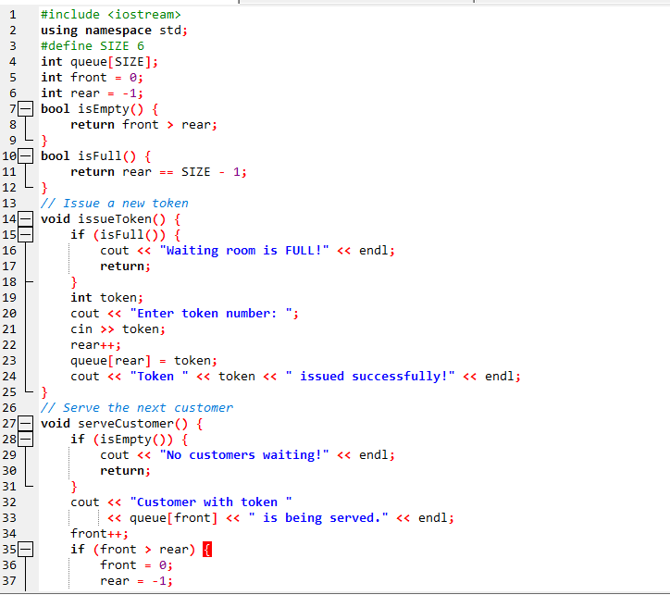
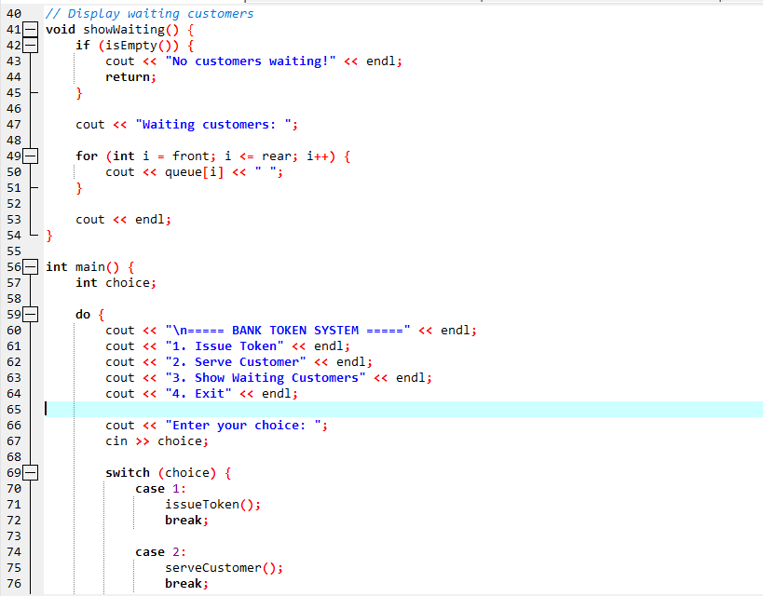
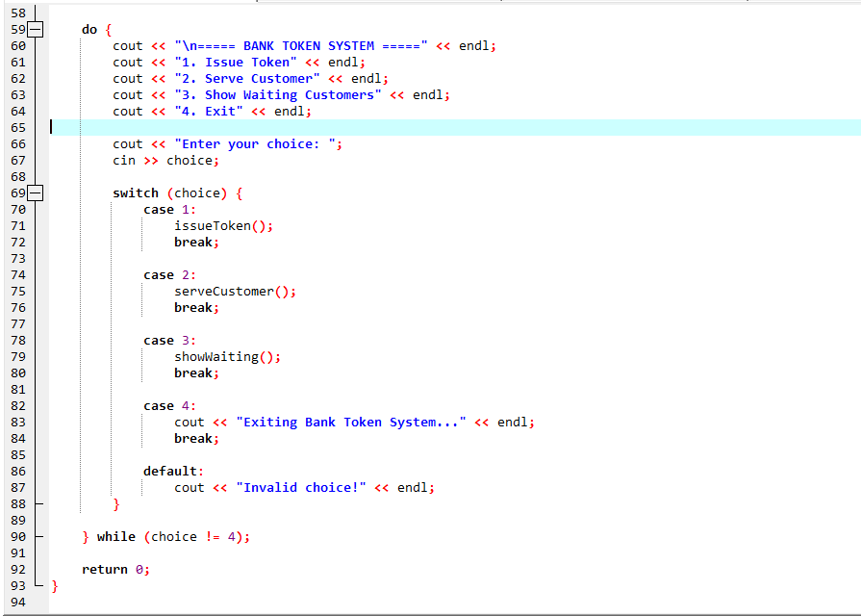
OUTPUT:
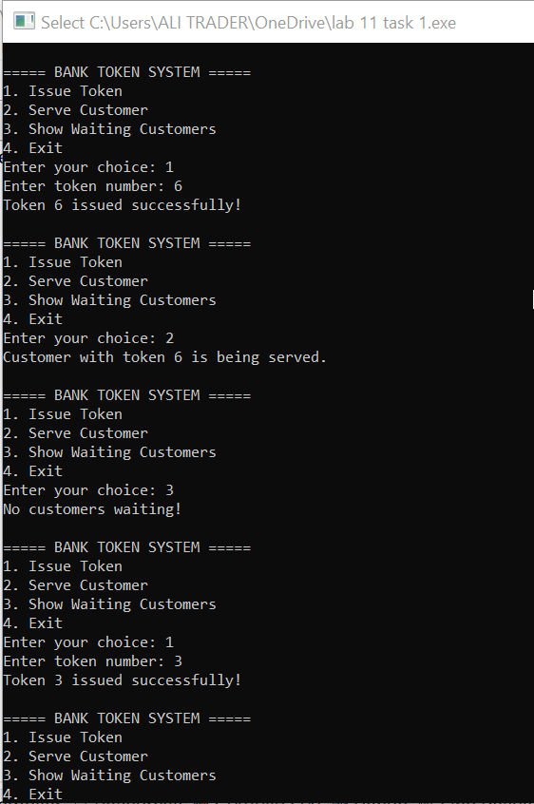
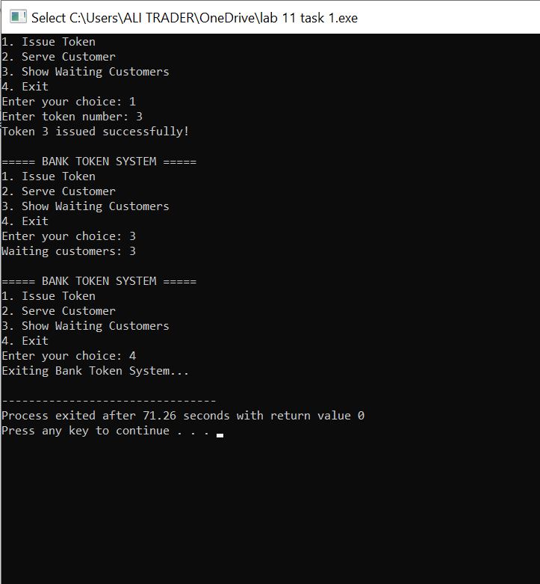
TASK 02
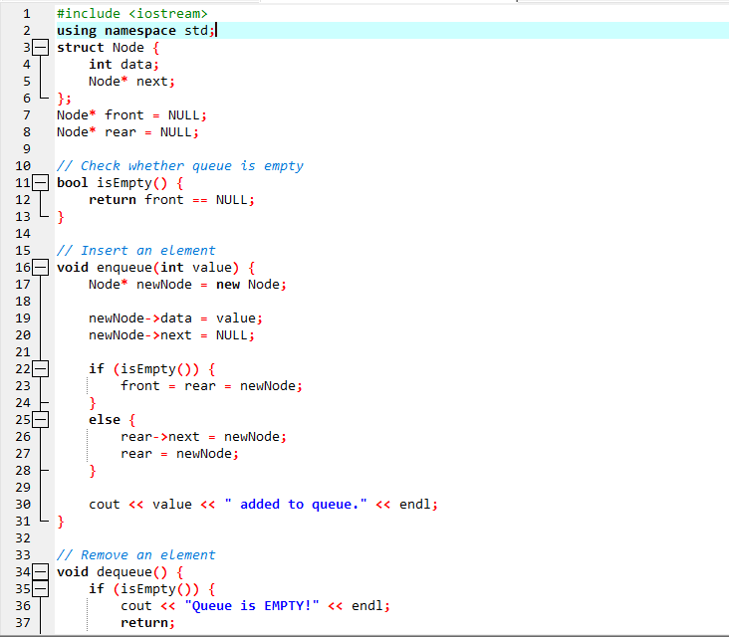
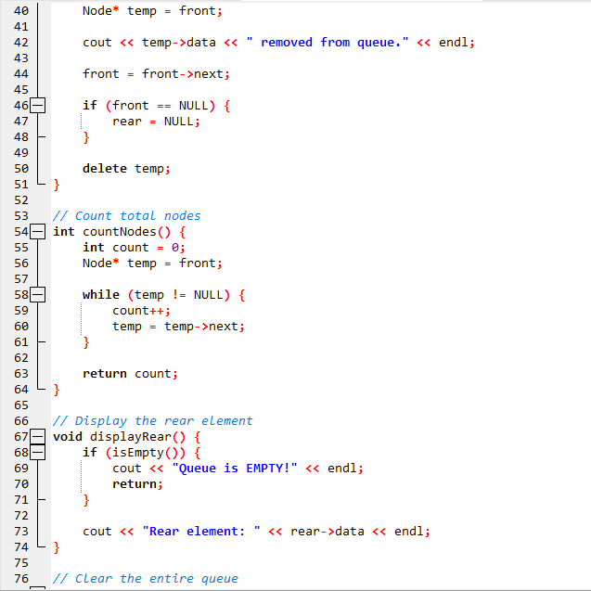
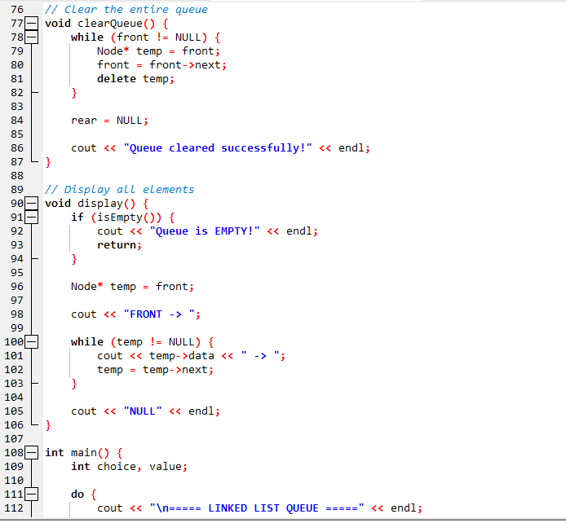
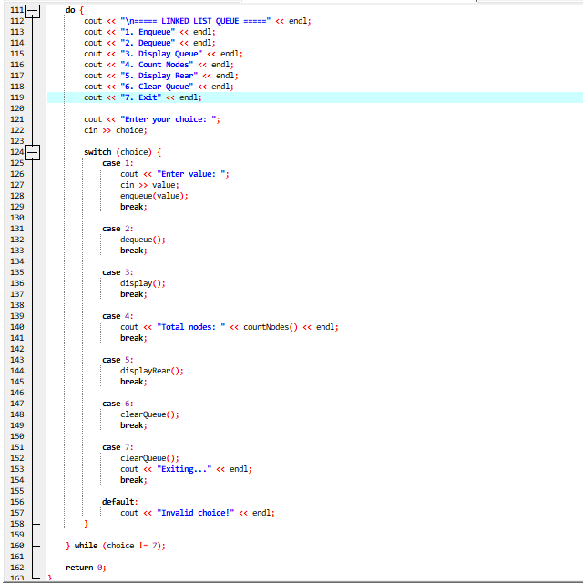
OUTPUT:
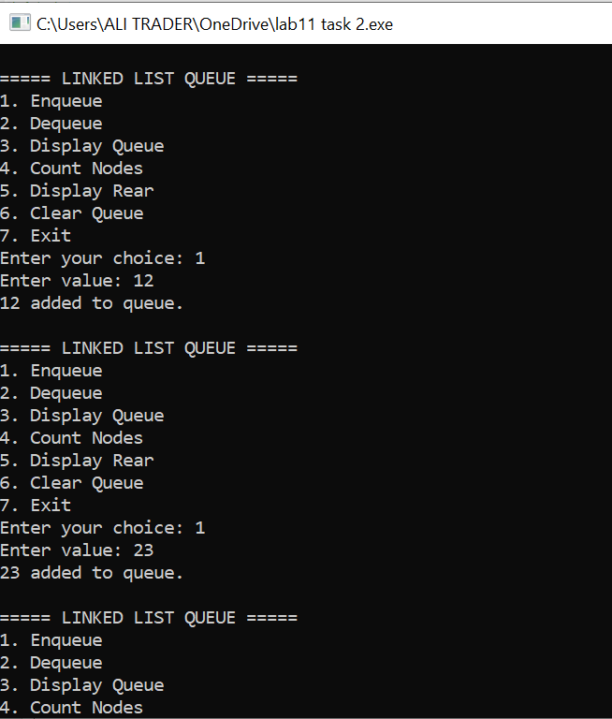
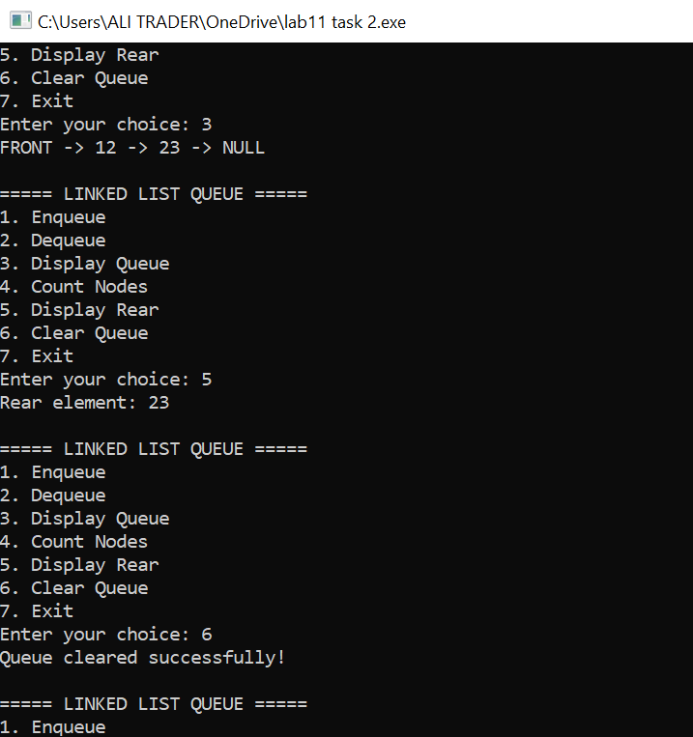
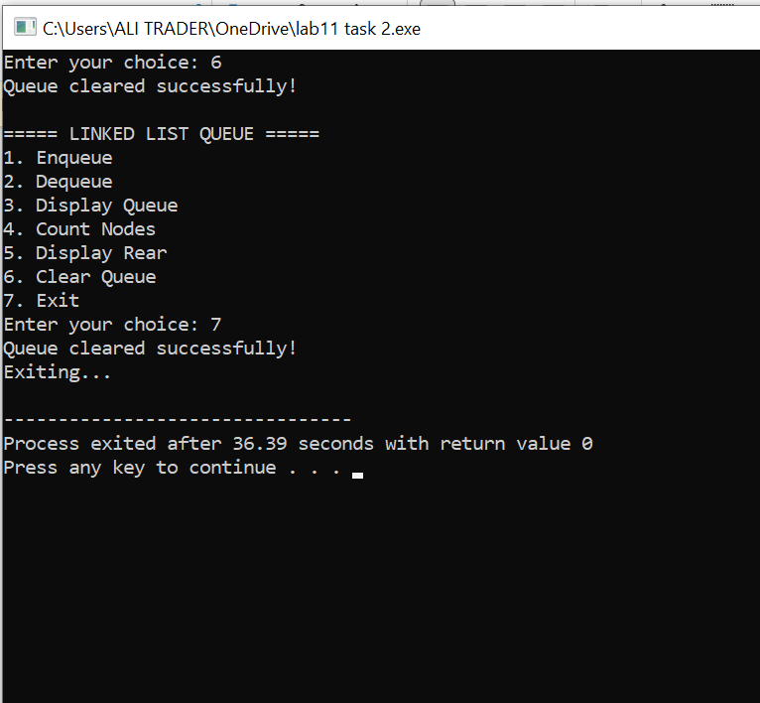

Task 03
Step | Operation | front | rear | count
1 | enqueue(101) | 0 | 0 | 1
2 | enqueue(102) | 0 | 1 | 2
3 | enqueue(103) | 0 | 2 | 3
4 | enqueue(104) | 0 | 3 | 4
5 | enqueue(105) | 0 | 3 | 4
6 | dequeue() | 0 | 3 | 3
7 | dequeue() | 0 | 3 | 2
8 | enqueue(105) | 0 | 0 | 3
9 | enqueue(106) | 0 | 1 | 4

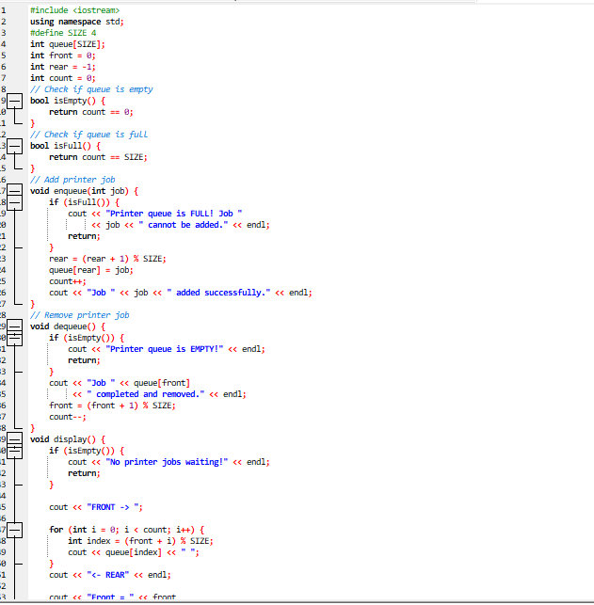
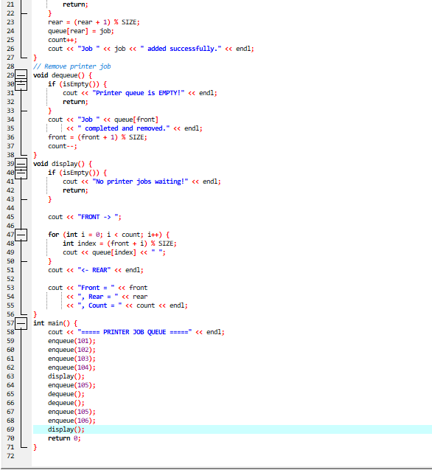

OUTPUT:
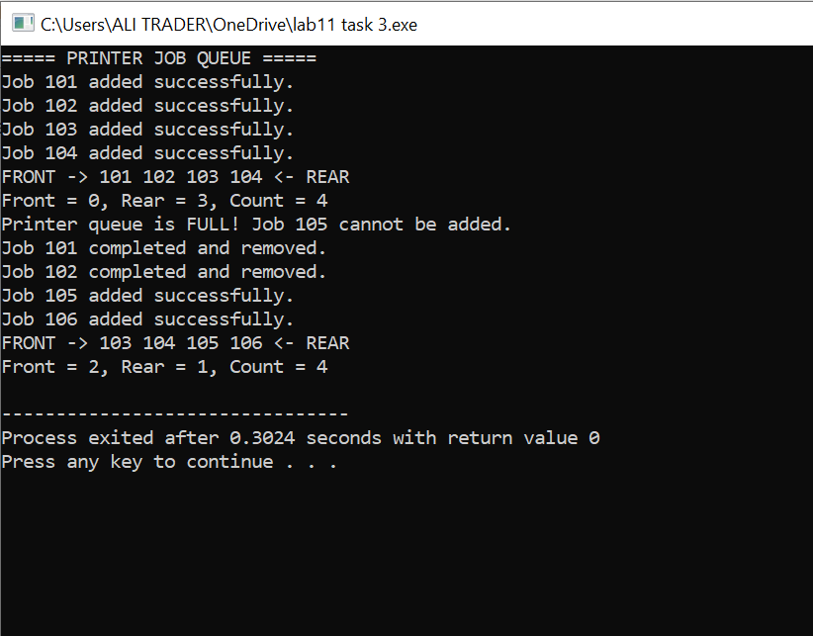
TASK 04
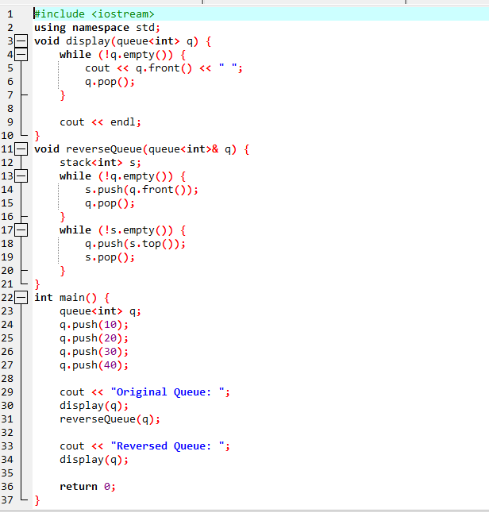

OUTPUT:


